**WEEK-2**

**MODULE -3**

**PL/SQL PROGRAMMING**

**SUPERSET ID:6407550**

**Exercise:6-Cursors**

-- Insert some transactions for this month

INSERT INTO Transactions (TransactionID, AccountID, TransactionDate, Amount, TransactionType)

VALUES (20, 1, SYSDATE, 200, 'Deposit');

INSERT INTO Transactions (TransactionID, AccountID, TransactionDate, Amount, TransactionType)

VALUES (21, 2, SYSDATE, 150, 'Withdrawal');

COMMIT;

-- Add new loans to see change

INSERT INTO Loans (LoanID, CustomerID, LoanAmount, InterestRate, StartDate, EndDate)

VALUES (5, 1, 60000, 6.0, SYSDATE, ADD_MONTHS(SYSDATE, 60));

INSERT INTO Loans (LoanID, CustomerID, LoanAmount, InterestRate, StartDate, EndDate)

VALUES (6, 2, 30000, 5.5, SYSDATE, ADD_MONTHS(SYSDATE, 36));

COMMIT;

**Scenario:1**

SET SERVEROUTPUT ON;

DECLARE

CURSOR trans_cursor IS

SELECT t.TransactionID, c.Name, t.TransactionDate, t.Amount, t.TransactionType

FROM Transactions t

JOIN Accounts a ON t.AccountID = a.AccountID

JOIN Customers c ON a.CustomerID = c.CustomerID

WHERE EXTRACT(MONTH FROM t.TransactionDate) = EXTRACT(MONTH FROM SYSDATE)

AND EXTRACT(YEAR FROM t.TransactionDate) = EXTRACT(YEAR FROM SYSDATE);

rec trans_cursor%ROWTYPE;

BEGIN

OPEN trans_cursor;

LOOP

FETCH trans_cursor INTO rec;

EXIT WHEN trans_cursor%NOTFOUND;

DBMS_OUTPUT.PUT_LINE('🧾 Customer: ' || rec.Name ||

' | Transaction ID: ' || rec.TransactionID ||

' | Type: ' || rec.TransactionType ||

' | Amount: ₹' || rec.Amount ||

' | Date: ' || TO_CHAR(rec.TransactionDate, 'YYYY-MM-DD'));

END LOOP;

CLOSE trans_cursor;

END;

/

**OUTPUT:**

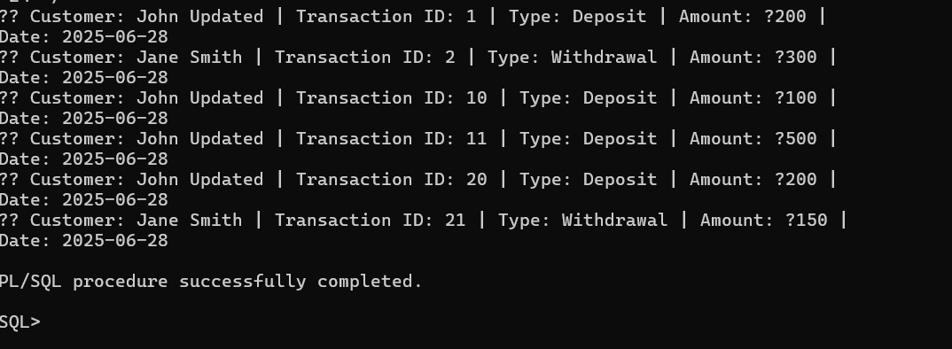

**Scenario-2**

SET SERVEROUTPUT ON;

DECLARE

CURSOR acc_cursor IS

SELECT AccountID, Balance FROM Accounts;

rec acc_cursor%ROWTYPE;

v_fee CONSTANT NUMBER := 100;

BEGIN

OPEN acc_cursor;

LOOP

FETCH acc_cursor INTO rec;

EXIT WHEN acc_cursor%NOTFOUND;

IF rec.Balance >= v_fee THEN

UPDATE Accounts

SET Balance = Balance - v_fee,

LastModified = SYSDATE

WHERE AccountID = rec.AccountID;

DBMS_OUTPUT.PUT_LINE('✅ Annual fee of ₹' || v_fee || ' deducted from Account ID: ' || rec.AccountID);

ELSE

DBMS_OUTPUT.PUT_LINE('⚠️ Insufficient balance for Account ID: ' || rec.AccountID);

END IF;

END LOOP;

CLOSE acc_cursor;

COMMIT;

END;

/

**OUTPUT:**

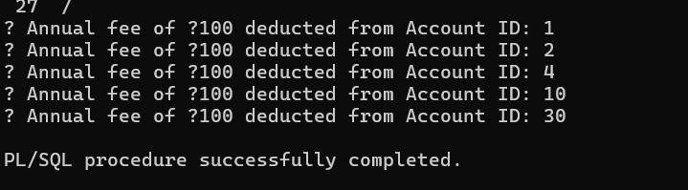

**Scenario:3**

SET SERVEROUTPUT ON;

DECLARE

CURSOR loan_cursor IS

SELECT LoanID, LoanAmount, InterestRate FROM Loans;

rec loan_cursor%ROWTYPE;

v_new_rate NUMBER;

BEGIN

OPEN loan_cursor;

LOOP

FETCH loan_cursor INTO rec;

EXIT WHEN loan_cursor%NOTFOUND;

IF rec.LoanAmount > 50000 THEN

v_new_rate := rec.InterestRate + 0.5;

ELSE

v_new_rate := rec.InterestRate + 0.2;

END IF;

UPDATE Loans

SET InterestRate = v_new_rate

WHERE LoanID = rec.LoanID;

DBMS_OUTPUT.PUT_LINE('🔄 Loan ID: ' || rec.LoanID ||

' | New Interest Rate: ' || v_new_rate || '%');

END LOOP;

CLOSE loan_cursor;

COMMIT;

END;

/

**OUTPUT:**

